Ribchester St. Wilfrid’s C of E Primary School
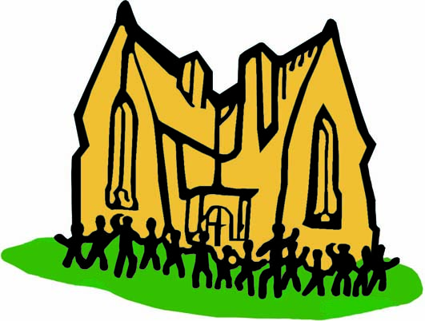
Curriculum Overview – Themes

Whole School Themes:
Theme Weeks to be taught throughout the years
 | Autumn Term | Spring Term | Summer Term
Even/Odd years | - Christmas | - Book Week  - Fairtrade / Eco Week  - Easter | - Multicultural Week
Odd/Even years | - Christmas | - Storytelling Week  - Fairtrade / Eco Week  - Easter | - Multicultural Week

Themes Days to be taught throughout the years
Bonfire night  (5th November) | St Andrew  (30th November) | St David  (1st March) | St Patrick  (17th March) | St George  (23rd April)
Remembrance Day | Gardening Day | E-safety Day | Maths Day | Science Day
Engineers Day | Composers Day | Circus skills Day | Team building / Problem Solving Day | Art / Creative Day

Reception, Year 1 and Year 2 – Calder and Hodder Classes
Themes to be taught throughout the year
Cycle A  (2014/2015) | Penguins, Possums and Pigs | Toys | Growth and Green Fingers | Family Album | The Great Outdoors | Robots
Cycle B  (2015/2016) | The Place Where I Live | Fighting Fit | Explorers | The Farm Shop | Wind in the Willows | Buckets and Spades
Cycle C  (2016/2017) | Traditional Tales | Bears | Fire! Fire! | Dinosaurs | People Who Help Us | Castles, Knights and Dragons

Year 3 and Year 4 – Ribble Class
Themes to be taught throughout the year
Even/Odd years | There's No Place Like Home | Healthy Humans | Rock and Roll! | The Iron Man | What the Romans Did For Us | How Does Your Garden Grow
Odd/Even years | Sparks Might Fly! | The Great Plague | The Art of Food | Passport to Europe | Water, Water Everywhere | Hunted

Year 5 and Year 6 – Wyre Class
Themes to be taught throughout the year
Even/Odd years | A Kingdom United | Food, Glorious Food! | Earthlings | Inventors and Inventions | Amazon Adventure | Faster, Higher, Stronger
 | Shakespeare
Odd/Even years | Survival! | Britten's Got Talent? | Heroes and Villains | Super Sleuth | Oh! I Do Like To Be Beside The Seaside

