

'simply school milk'
 01443 742112

info@milk4life.com @milk4lifeltd
www.milk4life.com

6th May 2025

Dear Parent,

Please find below guidance on ordering school milk for your child. The price for this will be £22.16 per term or £11.08 per half term. (This is subject to change).

Please visit our website www.milk4life.com

- You will need to click on the 'order milk' tab, register with us, add your child/children on the 'children' tab. (Please check your spam folder should you not receive your confirmation email).

OVER 5 CHILDREN
- Click on the 'payments' tab and you will then be able to select as many terms or half terms as you wish to pay for.
UNDER 5 CHILDREN
- Please input their date of birth and the system will allow to order without paying for the milk. PLEASE NOTE THAT THIS WILL NEED TO BE PAID FOR FROM THE MONDAY OF THE WEEK OF THEIR 5TH
BIRTHDAY. You will receive a reminder email for this - it will need to be ordered by the Tuesday the week before the free milk expires.

FREE SCHOOL MEALS CHILDREN

- If your child receives free milk under the FSM scheme then please contact the school, you do not need to register online.

Please place your orders for September 2025 by -

Cut-off date - MONDAY 28th August – 1pm

If you need anything further, please contact Sarah at sarah.gore@milk4life.com or 01443 742112. Yours sincerely
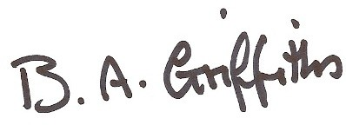

Barbara Griffiths
Milk4Life Ltd
Registered Office: 51A Margaret Street, Abercynon, CF45 4RB
Registered No. 8354385

