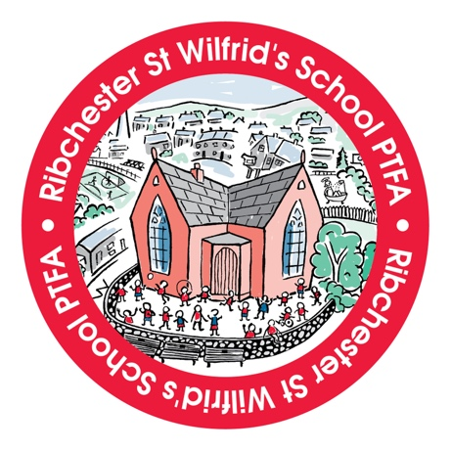

**Year 6 Leavers Hoodie Order Form**

Dear Parent/Carer,

The PTFA are delighted to gift each Year 6 child a leavers hoodie as a lasting memory of their time at St. Wilfrid's. These will be given to the children upon completion of their SATs in May.

Please complete and return the form below to ensure we can place the order accurately.

Thank you,  
Ribchester St Wilfrid’s PTFA

**Child’s Name/Nickname** *(as you would like it to appear on the reverse):*

**Child’s Initials** *(as it is to appear on the front):*

**Size Required** *(please refer to the size guide below):*

**Size Guide:**



**PLEASE RETURN THIS FORM TO SCHOOL NO LATER THAN FRIDAY 28th MARCH**